**Assignment – Student Data**

Shaun Pritchard

Rasmussen College

QMB3200

Kimberly Powell

July,12 2020

**Assignment – Student Data**

I implemented using three different formatting types for SAS the freeform input method which is easy to specify allows me to add columns positions for data entry and data that is separated by blanks this is a very quick and easy way to get data into SAS manually.

I then use the column input format which is similar to the free-form app not that accept all of my data resides without any spaces. This is another technique for reading data into SAS that should only be used when data consists of fix Columns of values that are not separated by blanks

finally, I use the format input method which is another technique for reading data similar to The column input method that allows me to use the reserved function FORMAT to alter output of data in a given column.

SAS Script code:

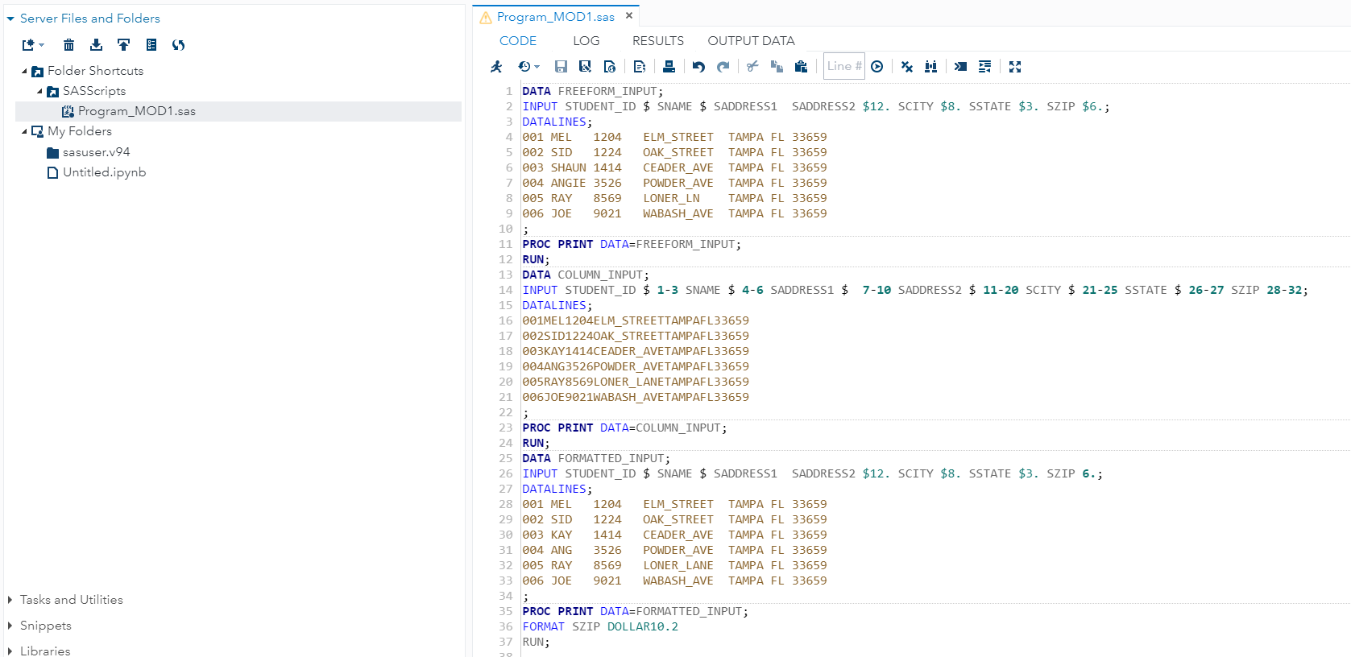

SAS Scripting OUTPUT:

